**Simplilearn Capstone Project**

**Developer Details:**

Developer Name: Vodthala Avinash Goud

Email: [avinashgoud98765@gmail.com](mailto:avinashgoud98765@gmail.com)

Date:8th August 2022

Version:1.0

**Objective:**

To build an application where user can register, login, filter, search and order products by paying the desired amount according to the order.

**Features:**

Using our application as a user you can Login to our application and search, filter and add products to the cart and then place the order.

Admin can login and:

-manage products

-manage users

-manage orders

-logout

**User Interaction:**

1. User should login by using their personal credentials

2. By selecting various options user will get the following options:

* Filter Products
* Search Products
* Add to Cart
* Update cart
* Place order
* Make the payment
* Logout

3. On the other hand Admin can do:

* Login using credentials provided
* Manage products by add/delete/update operations
* View users
* View orders
* Logout

**Sprint Planning:**

Number of Sprints Planned: 5

Duration of 1 sprint =5 days

The following are the sprint details:

Sprint 1:

* Collected requirements
* prepared flow chart diagram.
* Added Developer details and Main Menu

Sprint 2: Added Business level Operations for Frontend

Sprint 3 : Added Business level Operations for Backend

Sprint 4: Running the application together Frontend and Backend

Sprint 5:Testing the application using various inputs, Documentation

**Technology Used in the Project:**

* Front End:

HTML

CSS and Bootstrap

TypeScript

Angular, Angular Material for view

* VS Code: An IDE to design frontend of the application
* Git: To connect and push files from the local system to github.
* GitHub: To store the application code and track its versions
* Scrum: An efficient agile framework to deliver the product incrementally
* Backend:

Eclipse IDE

Java Programming

Searching and Sorting

Spring Boot DevTools

Spring Web and Spring Data JPA

MySQL

**Modules in the Project:**

* Registration Page
* Login Page
* User Login
* Admin Login
* Dashboard
* Search Products
* Add Cart/ View Cart
* View Previous Active Orders
* Payment Gateway Page
* Order Summary Confirmation Page

**Diagrams:**

**1.Flow Chart for Admin:**

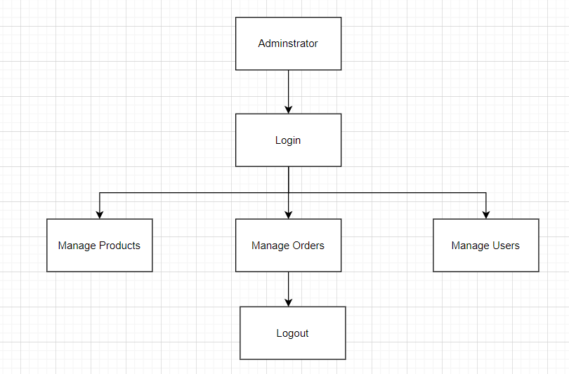

**2.Flow chart for User:**

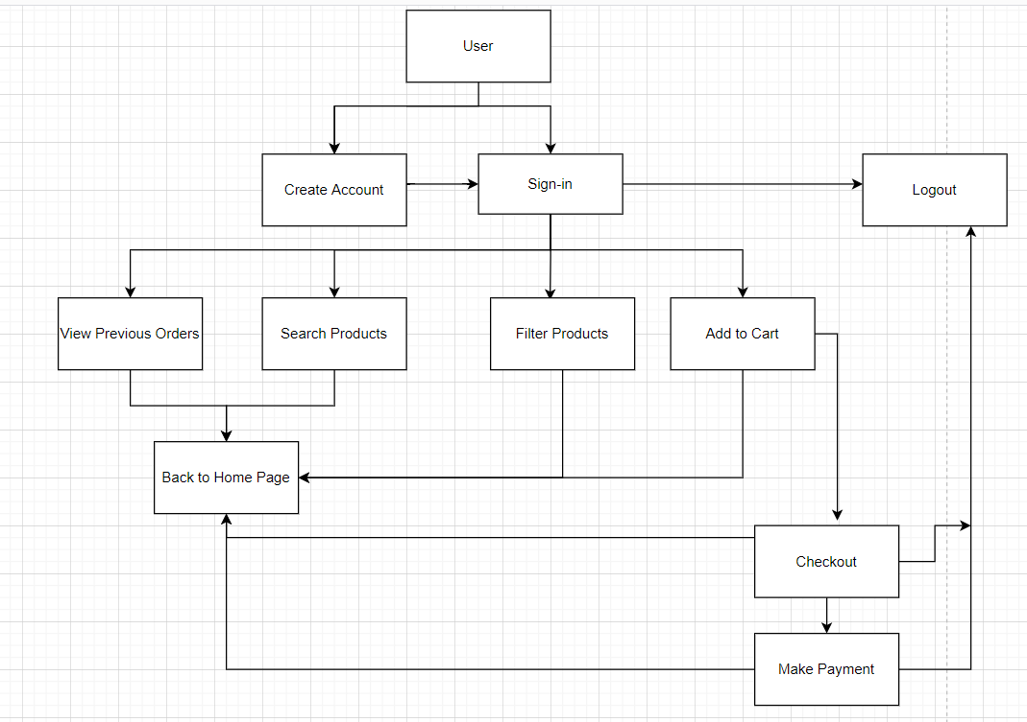

**Git Hub Details:**

Github – It is open source application to create remote repository and store our project details.

**Git hub commands used:**

* Git init: To initialize the git repository in local
* Git status: To show the details like commited files, untracked files
* Git add . : To add the untracked files to stages area
* Git commit –m “Added Simple Project”: To commit in local area
* Git log: To display the number of commits you already did
* Git log –oneline : To display commit id which are in local
* git branch –M main:Rename master branch master to main
* Connect locale to remote repository.
* git push origin main / git push -u origin main: To push our commits to remote repository

To connect local and remote repository we can use the below link:

git remote add origin : https://github.com/avinashgithub1/capstone-project.git

**Conclusion:** By using this application admin can manage the products, view orders, view users etc. Whereas user can filter, search and add products to the cart and then make the payment after which user get order summary. We can enhance this application further by adding more functionalities.